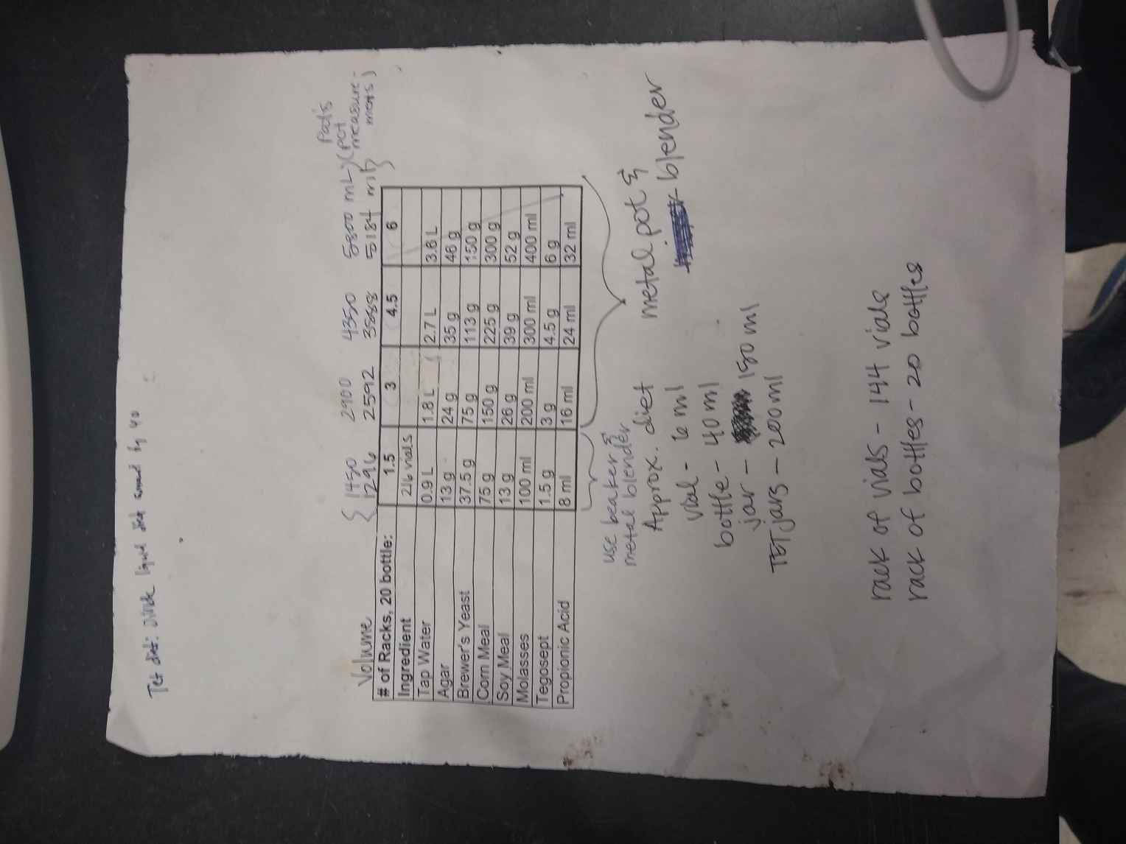

<https://www.rockefeller.edu/research/uploads/www.rockefeller.edu/sites/8/2018/10/Fly_Food_Protocol.pdf>

|  |  |  |
| --- | --- | --- |
|  | Yield: 2.0L | Yield: 3.0L |
| Water | 0.6L | 1.8L |
| Agar | 8.66g | 26.0g |
| Brewer’s Yeast | 25.0g | 75.0g |
| Corn meal | 25.0g | 150.0g |
| Molasses | 8.66g | 26.0g |
| Tegosept | 1g | 3.0g |
| Propionic acid | 5.33mL | 16.0mL |

1. Bring water to a boil with a stir bar
2. Add agar to boiling water and mix thoroughly
   1. Once boiling, yeast. Continue heating for 5 minutes
3. Transfer boiling solution into a blender and add:
   1. Corn meal, soy meal, and molasses
4. Add 30% tegosept solution in ethanol and 25% propionic acid solutions into prepared mixture (broad spectrum fungicides)
5. Mix for 5 minutes
6. Pour while warm